**REPORTS**

The **Reports** tab includes all available text-based reports, such as: dictated reports (e.g. history & physicals, consultations from specialists, and discharge summaries from a hospitalization), office visit notes, operative notes, radiology reports, imaging studies, and miscellaneous correspondence.

Reports of similar type are grouped together and shown in order by date with the most recent report shown first.To display the text of the report, click the title of the report. The contents will be displayed to the right of the list.

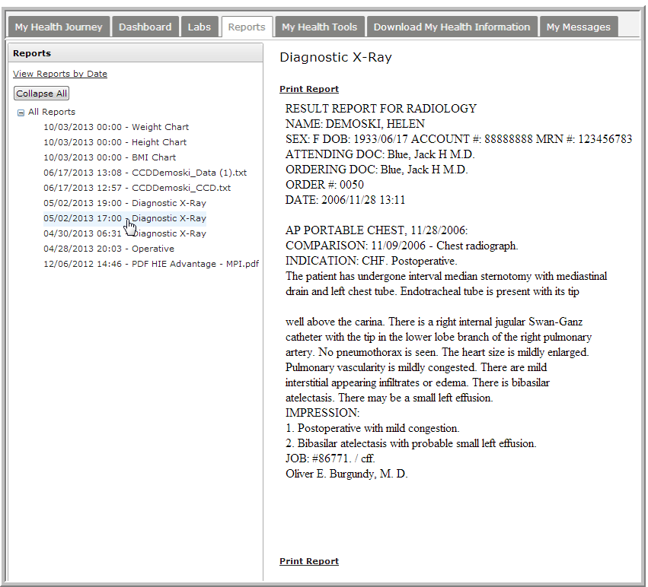

If you prefer to view reports in chronological order, rather than by category, click **View Reports by Date** above the list of reports on the left.

